* Employee is able to see and fill performance review page without being assigned to a manager
* When employee review is saved as draft, the review is actually submitted and an email is still sent to the manager saying a performance review has been submitted. The manager should not be able to view this draft.
* When employee review is saved as draft, they can no longer edit it and cannot see submit button.
* After employee either saves as draft or submits review, top four questions and answers in self-appraisal are missing for both employee and manager. The below screenshot was filled in review but was missing after submission.

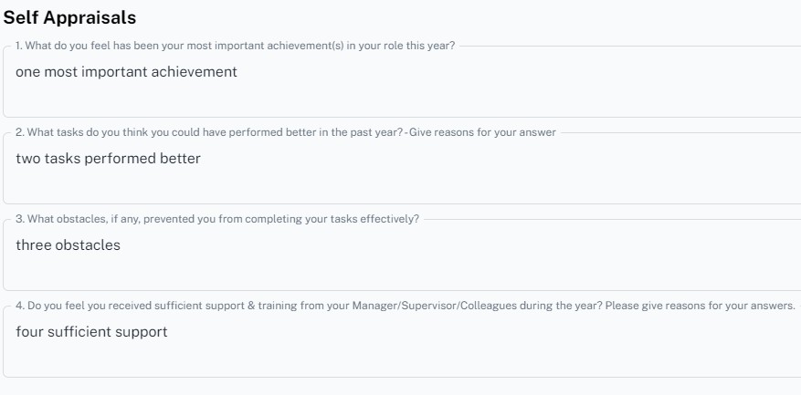

* After employee either saves as draft or submits review, all competency scores and comments are incorrect on subsequent screen, for both manager and employee. Section 3 Objectives are correct, but “Areas

Identified for Training & Development” is also missing the value.

**FINAL OUTPUT**

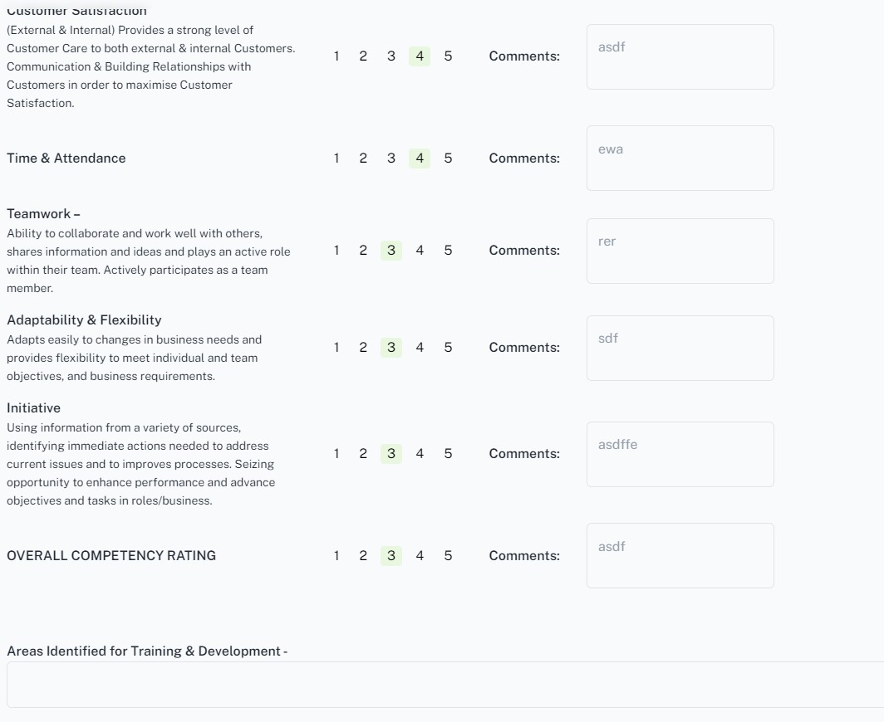

**ACTUAL INPUT**

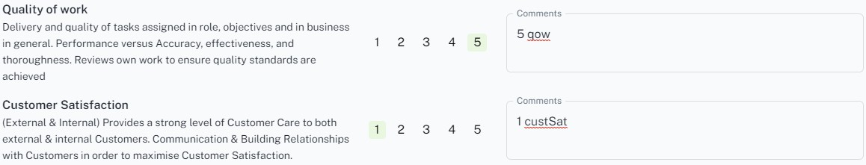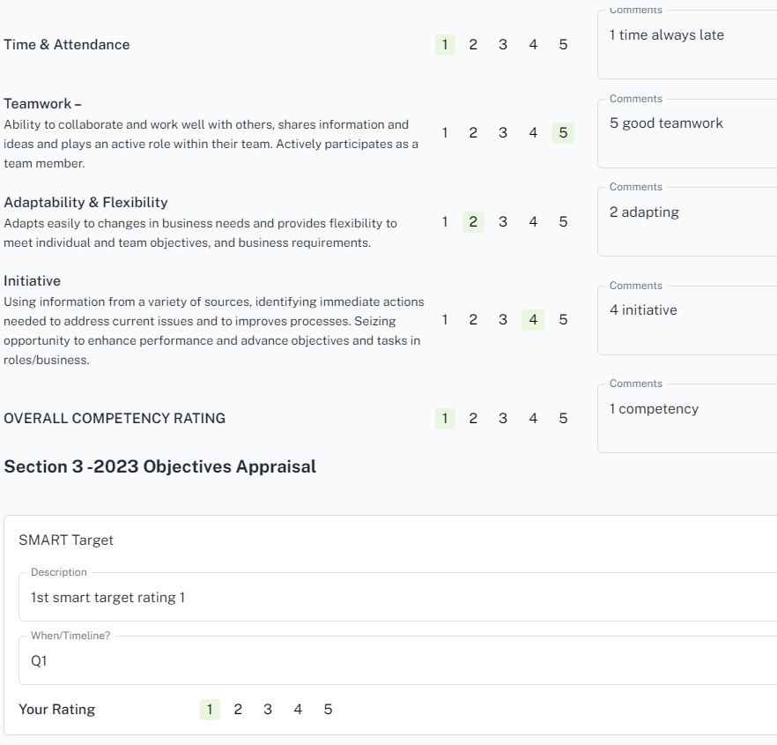

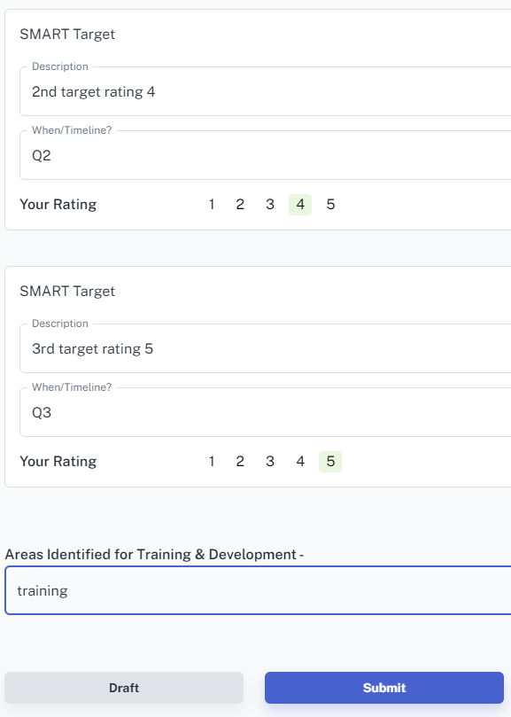

* Also on same screen, “Manager Rating” shows result even when manager has yet to fill review. “Your Rating” value is different to overall competency rating (showing 5 here, employee filled 1 in overall competency, and incorrect values in review screen shows 3).

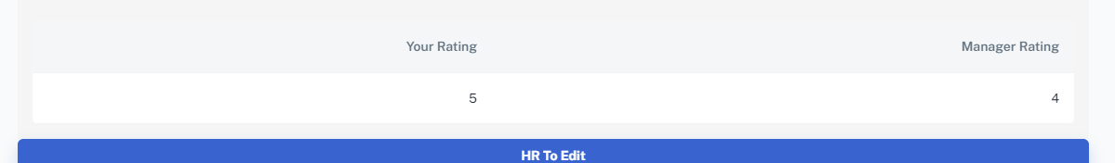

* The above screenshot is similar when manager is reviewing. Manager Rating is filled by default with no option to change.
* 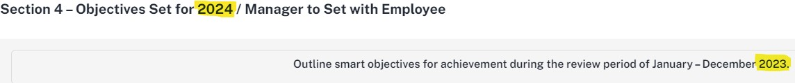Years mismatch as per image
* If manager is reviewing and saves as draft, when they open the page again, no comments/scores have been saved
* After manager fills in all available fields, pressing the Submit button does nothing.
* 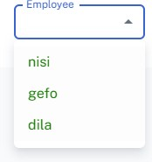For manager, when selecting employee from drop-down, all employees are showing in green font. Employees who have submitted reviews should be amber. (Should be as discussed on call, Green : Both completed review; Amber : Only employee completed review; Red – Employee yet to complete review)
* Employees are listed in previously completed reviews even though they have not been completed by the manager. Clicking on a folder of an employee does nothing.

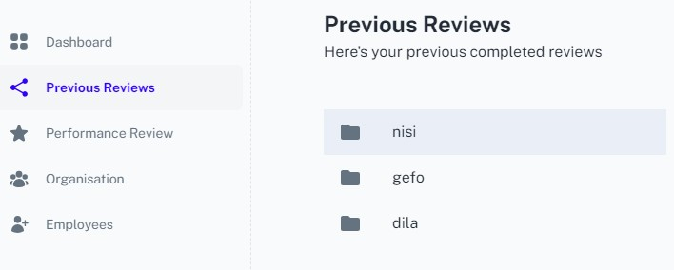

* In Performance Review, if a manager is not a subordinate of another manager, and they switch to Self-View, they are given a review form to fill in. Since they have no manager, they should not see a form.